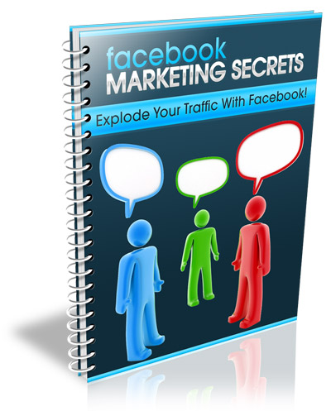
Table of Contents
Introduction 3
Create Targeted Advertisements 4
Improve your Click Through Rate 5
Stay Within Facebook Guidelines 7
Setting Your Maximum Daily Bid 7
CPC Versus Impression Based Ads 8

Get Your Free Bonuses Here . . .
To say “Thanks” for taking the time to read this guide, I’ve put together a special page full of free bonuses for you. These are all great resources, and can all help your business in some way.
Have a look at the following page, and get the bonuses that can help you with your business . . .
www.GetYourFreeBonuses.com

Introduction
Facebook is the leading social community online. With over 300 million users, there has never been a better way to maximize your exposure, and get your message seen by a massive customer base.
The greatest thing about advertising with Facebook, is the flexibility of your advertisements.
You can customize your advertisements so they appear only to specific groups or segments of people based on the information contained within their profile or based on gender, location or personal preferences.
For example, if your product is tailored towards single mothers, you could develop your advertisements so that they are triggered to appear only for those who have indicated that they are single mothers in their profiles, or who have demonstrated interest in similar products or services based on their personal profile, communities or groups they've joined, or other advertisements they've responded to.
Let’s get started!

Create Targeted Advertisements
In order to create the most compelling, responsive and profitable advertisements, you need to utilize Facebooks option to heavily target and tailor your advertisements based on your target market.
With facebook, you can set your ads up so that they appear only to specific people, based on age, location, gender, interests, hobbies or even based on the groups they have joined within the Facebook community.
You will want to conduct market research so that you can accurately define your target market and develop advertisements that target specific segments of your market.
Facebook implores a quality control system to ensure that the advertisements that run throughout their community stay within their guidelines and do not offend or disrupt member activity or overall experience.
Use their quality control system to develop compelling advertisements that stand out in the marketplace, and capture the attention of potential buyers.

Also keep in mind that Facebook advertising is based on display, rather than search. This means that your ads will be automatically triggered to appear based on your settings, rather than when a user conducts an on-site search.
Users can also choose to rate advertisements, helping to retain quality throughout the community.

Improve your Click Through Rate
Your advertisements click through rate plays an integral role in saving you money while boosting exposure and reaching out to your target market.
It’s important to keep a pulse on your click through rate so that you can correct any problems with your advertisement, or make adjustments to improve your overall CTR.
If your advertisements CTR drops too low, it could be automatically paused or removed by Facebook, so you really want to pay attention to how well it’s converting.
Typically, your ads should never fall below a 2% conversion rate.
One of the easiest ways of increasing your CTR is by creating a highly targeted advertisement.
You want your ad to appear only to those who are within your target demographic, while making sure that your advertisements text or any images used speak directly to your customer base.
Consider split testing various advertisements within the Facebook community to determine what works best, based on your industry or niche market.
You should also pay attention to the times of day that your ads appear. You can choose to either run your ads consistently throughout the day, or have them only appear at specific times (or even specific dates).
Keep in mind the time zone of your target market, so that your ads are running based on the most active time of day or night.

Stay Within Facebook Guidelines
It’s important to understand how Facebook advertising channels work, and what is permitted as well as what is not allowed within the marketplace.
Facebook is very flexible with the types of advertisements that are allowed to be displayed within their community, however they do not allow images or text that may be considered offensive.

Setting Your Maximum Daily Bid
One of the most important aspects of setting up an effective Facebook advertisement is in the maximum daily bid that you are willing to pay. The higher your daily bid, the more exposure your ad will receive.
You want to start off with a lower bid if you are just getting used to advertising with Facebook, and increase your maximum daily bid as you fine-tune your advertisements for maximum results.
It’s important to always keep a pulse on how well your advertisement is converting, so that you can improve click through rates and overall response.
When you create an advertisement with Facebook, they will suggest a maximum bid based on your advertisements focus and target market (based on your personal configuration and preferences).
You can start off by setting your maximum daily bid slightly lower than what’s suggested and increase it as you improve your advertisements conversion rates so that you are getting the most bang for your buck!

CPC Versus Impression Based Ads
With Facebook, you can develop advertisements where you either pay for impressions or based on the number of clicks your ad receives.
If you are just getting started with Facebook advertising, I recommend choosing cost per click (CPC), so that you can accurately test your advertisements, while paying only for responses rather than just views.
You can always change your advertisement format to ‘impression based’ later on in the event you wish to test out alternative options.
I wish you the best of success!

